**192111711**

**S.Shahul**

**19. Install a C compiler in the virtual machine created using virtual box / VM Ware Workstation / Player and execute Simple C Programs.**

**VM with Installing C Compiler:**

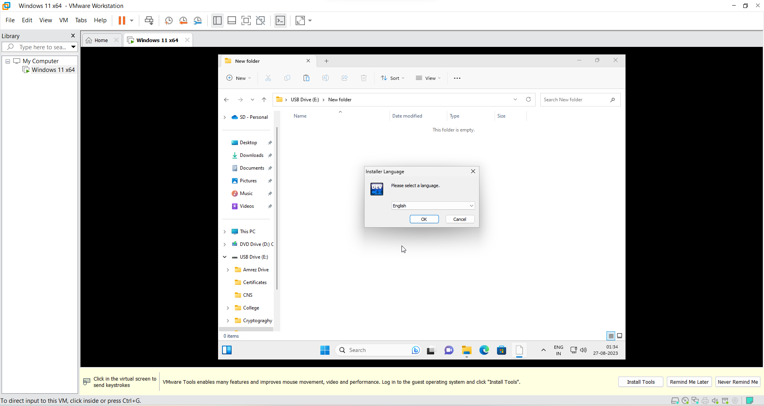

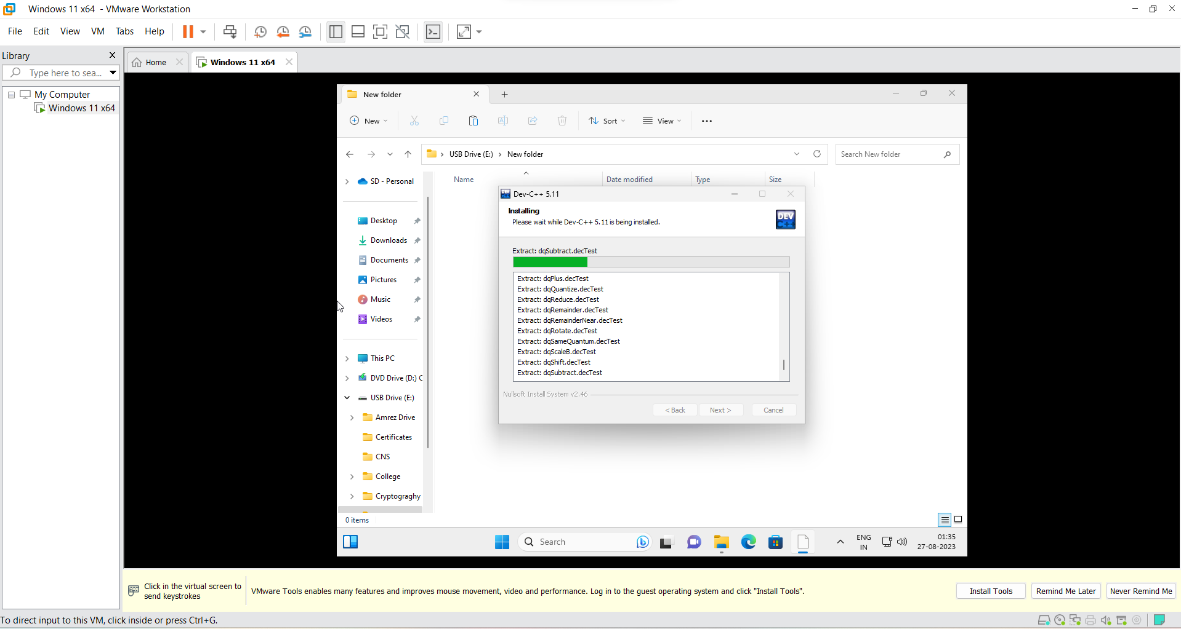

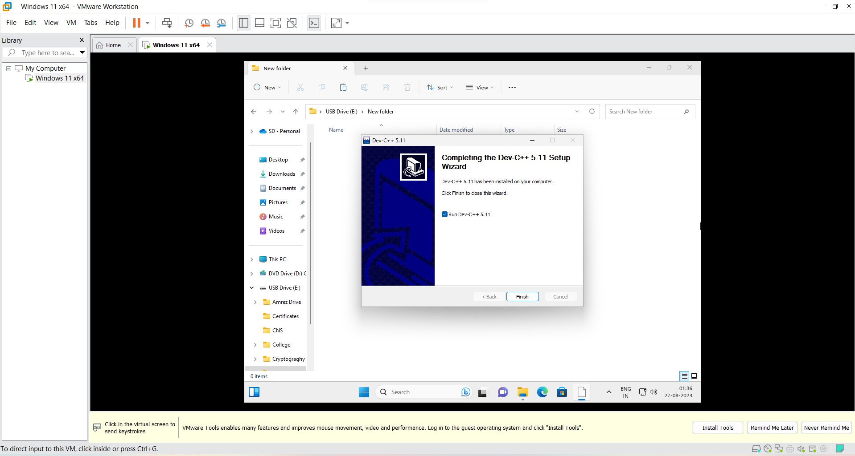

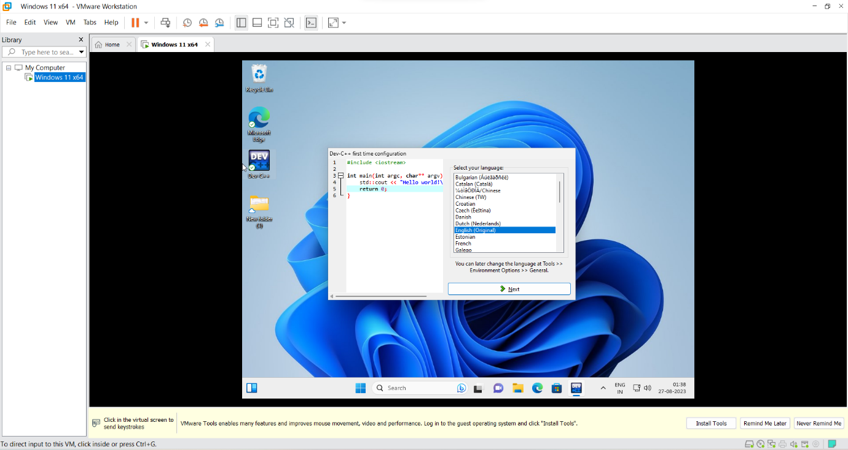

**VM with running Arithmetic operation using C programming:**

